Just Beneath Reality

‘Civilised life, you know, is based on a huge number of illusions in which we all collaborate willingly. The trouble is we forget after a while that they are illusions and we are deeply shocked when reality is torn down around us.’
–J.G. Ballard

This exhibition brings together five intriguing painters from Hungary, the Czech Republic, Moldova, Spain and Russia whose practices engage, in distinct ways, with both figuration and abstraction. While the featured artists have different degrees of realism within their practices, for each of them painting offers a means of exploring worlds that lie just beneath the surface of reality. Whether in the form of illusions or enigmas, memories half-recalled, altered states of mind, surreal visions or the nightmares of a troubled mind, the works in the exhibition evoke a subconscious state of being in which truths become confused, facts slip into mysteries, and real life merges with fiction. ‘Just Beneath Reality’ presents us with a glimpse of the underworld of painting.

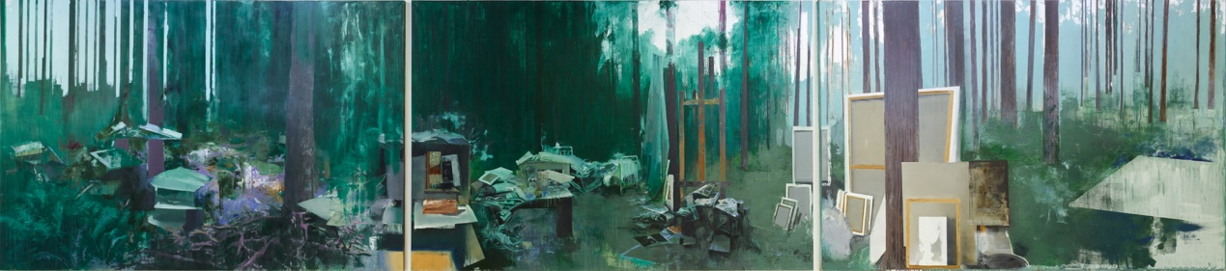

In St. Petersburg-born and based Vitaly Pushnitsky’s immense triptych Tribute (2018) the viewer encounters an artist’s studio outside in the landscape – the whole studio is en plein air. In the central panel, a tall easel stands empty, facing a clearing in the woodland surrounding it, the stark bright light of the sky piercing the canopy of turquoise, teal and dark green foliage that is periodically punctuated by slender tree trunks. In front of the easel and around the improvised studio space are wonky stools covered in books, catalogues and newspaper cuttings, a nearby table similarly piled up with the usual artist’s clutter. To the right, spilling out into the third panel, the stretched canvases familiar to every painter’s studio can be seen leaning against each other, their fronts facing away from us. The only painting visible is the one that Pushnitsky has made to depict the scene, the triptych we are looking at, as if it is, somehow, the result of work in the outdoor studio itself.

The central panel is painted in the most detail, and while much of the foliage is painted with loose, almost abstract marks, there is a sense of realism that underlies the painterliness. From a distance, or in a tiny reproduction, one might be forgiven for mistaking the image for a photograph – of the three panels it most closely resembles perception of real space. In the right-hand panel, the stacked canvases, the tree trunks and greenery are more simply, flatly painted and they gradually fade away to the right, leaving exposed canvas and broad glazes of underpainting open to the elements. This third panel feels almost like a painted sketch, or a painting in progress – one in the process of becoming more like the middle panel. It is a step further removed from reality, though is clearly on the way towards it. Reality, if painting is to be believed, is not a pre-existing or singular state, but is brought into being, and can just as easily be dismantled.

The first, left-hand panel is the most abstract of the three. Beyond the delicate leaves of some ferns in the foreground, the artist’s bric-a-brac, strewn about the woods, is overrun by the landscape, like a wasteland that nature is gradually reclaiming. The paint becomes increasingly abstract, with passages verging on expressionism. It is considerably more worked into than the third panel yet yields little more visual information – it feels as if the detail is there but cannot quite be deciphered. Abstraction, by its very nature, is also a step removed from reality and Pushnitsky’s triptych implies that the abstraction presented here somehow goes beyond reality: it is more akin to the ‘other’ side, or the falling apart, of reality than to the creation of it. Abstraction as it manifests here might be said to have something in common with entropy, an inevitable cycle of life and death. In the eerie green half-light of the forest, Pushnitsky’s studio is more like an apparition or an allegory than a depiction of a real space – for the artist, through the endless possibilities of the canvas and of their own imagination, the studio has no walls. The artist’s mind’s eye can often go far beyond their physical eyes and real space, and it is here that reality’s complex yet fragile relationship with consciousness comes to the fore.

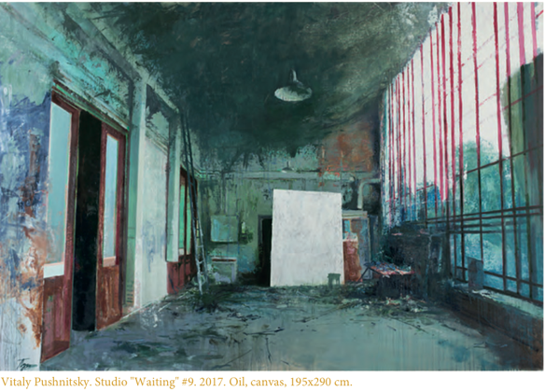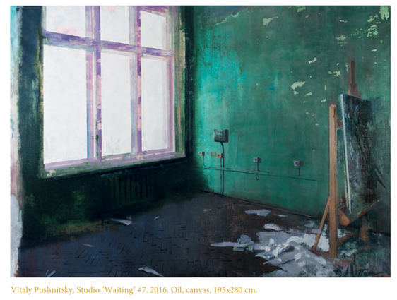

In Pushnitsky’s paintings Studio ‘Waiting’ #9 (2017) and Studio ‘Waiting’ #7 (2016) we find the exact opposite – artist studios that have been all but emptied out. Perhaps Pushnitsky has decamped to the forest. In Studio ‘Waiting’ #9 the floors are clear though the smears, stains and scuffs common to many painters’ studio floors are still present. The walls, often covered with postcards, drawings, studies, magazine pages and so forth, are bare, though again show the tired signs of long-term artist use and gradual deterioration or decay. A workbench and a couple of canvases are propped up against the far wall, with cool, green-tinged light saturating the scene from the floor-to-ceiling windows on the right. It’s as if the artist is in the final stages of moving out or has already gone and just left a few things he could not take with him. In Studio ‘Waiting’ #7, a canvas rests on an easel, its back facing towards a large window that has pure white light flowing through it. Some torn up paper or cloth around the feet of the easel covers the parquet flooring beneath. The studio tells us little more, and there is nothing that can be seen in the white void outside – it’s as if all that exists is the basic fabric of the room and the painting itself – this is Pushnitsky’s reality. The resulting paintings, needless to say, are haunting and exquisite in equal measure, hovering somewhere between reality and ethereality.

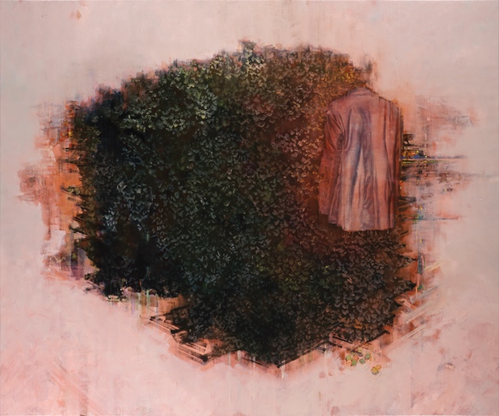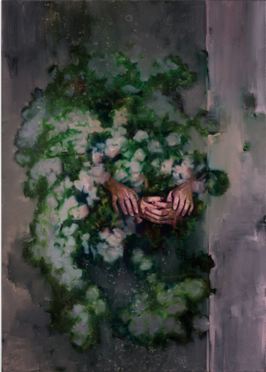

Budapest-based Attila Szücs leads us even further from reality, a painting such as The Meaning Extinguisher (2017-18) seeming to collage the very fabric of space-time. Out of a monochrome, dusty peach ground emerges a large bush, as if creating, or seen through, a gaping hole. It conjures a mental image of a wormhole in outer space. The edges of this odd chasm are abstracted, though with its parallel and perpendicular short, dark, rectilinear lines, there is a slight suggestion that there might be elements of a distantly viewed landscape or cityscape buried beneath, largely obliterated by the incursion of the bush. While the city’s existence is uncertain, the dense foliage of the bush is clearly visible, illuminated from an unknown light source above, though a second light, with a spectral, sickly, orange-red glow hangs over the right-hand side of the bush like fog, where a man’s jacket floats in the air, viewed from behind. From its shape, it looks as though it is being worn, but there is no head, there are no legs. The implication is that the unseen wearer is standing right next to the bush, staring straight into it, as if being punished or forced to do so. What are we to make of a disembodied jacket in front of an apparition of a bush ripping through the centre of a landscape that is on the verge of fading into complete colour-field abstraction? While its meaning is unclear (and the title implies it might never become so), we are left with both a sense of the immediacy and intimacy of the physical world around us and the vastness of the universe – our world in microcosm and macrocosm simultaneously. In the painting Emerging Hands (2018), we are similarly stuck in a bush surrounded by the abyss, but this time two pairs of hands are the only signs of human life to be seen, anxiously clasped as if prayers for – or from – the afterlife. With an existential malaise and metaphysical anomie characteristic of Szücs’ impressive and cryptic oeuvre, these paintings not only bring our physical, corporeal existence into sharp relief against the entire universe of physical matter, but also propose that our life-force, our very consciousness, is trapped helplessly between the infinitesimal and the infinite.

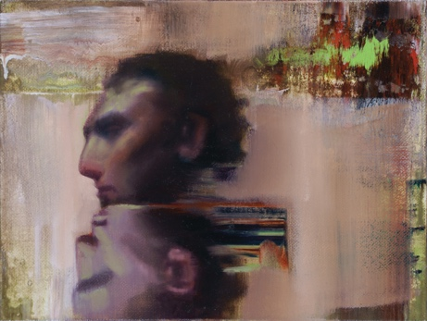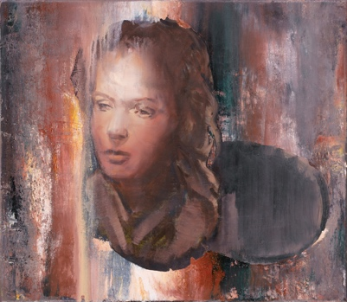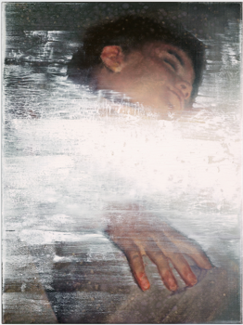

As followers of Szücs’ work will know, this is not the first time he has explored the relationship between disembodiment and abstraction, exemplified by works such as Floating Head (2014) and Illuminated Female Head (2015), both of which depict disembodied heads, alive (or seemingly so), emerging out of and being consumed by painterly abstraction. In the painting Sleeping Girl (2018), the head of a child can be seen amidst a sea of bright white paint. Like white noise or digital interference suggestive of subconscious brain activity, the girl lies in peaceful sleep blissfully unaware of the cosmic microwave background radiation from the Big Bang that surrounds her. She is the universe, and has always been. Like snippets of information that have slipped out of memory and become momentarily lodged in some remote part of the universe, parallel or otherwise, these works are evocative of data glitches in the fabric of the cosmos. As Szücs once commented: ‘Everything is possible!’

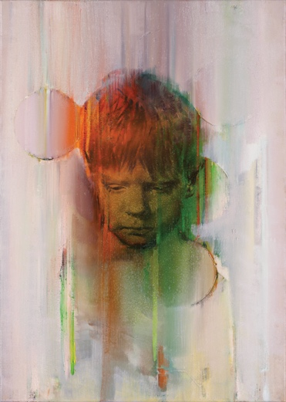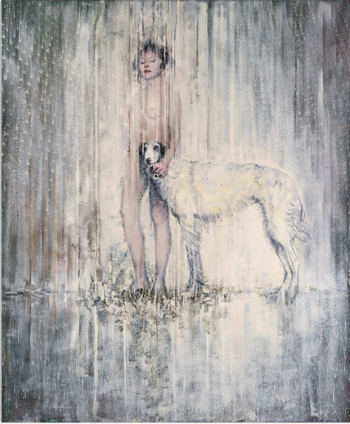

In the painting Melancholic Portrait in Red and Green (2017-18) we encounter the head of a young boy facing straight towards us, though with his eyes staring downwards. His expression is serious, perhaps melancholic as the title suggests, as if contemplating a loss. His hair, a light, golden brown, is lit on the left-hand side by a warm red light from a fire or an artificial source. The right-hand side of his head and face is bathed in a dark green shadow, the colour-wheel opposite of the red on the other side. His face, a combination of orange and yellow from the mixing of the red and green light, is grainy, with watermark-like circular blips and vertical striations descending over the top, dragging the dirty pink abstraction that surrounds him into a colour spectrum that is discernible to the human eye. Out of the swirling mists of nothingness, light appears and forms visual imagery, figuration. Like a flickering projection in a foggy netherworld, Szücs’ boy is an apparition in colour formed of light, a chance meeting of waves and particles made real through our perception of him. Vertical striations are also a prominent device in the painting Standing on a Horizon (2018), in which a naked young woman stands with her arm around the neck of a tall white dog – possibly a Russian wolfhound. White lines engulf them like sheets of rain, with dappled white marks visible in a gentle arc behind. Their feet are placed on the horizon, suggesting we are looking up towards them from ground level, only the ground itself might be just a reflection. It is an elegant and poetic work, evocative of an apparition emanating from somewhere in the multiverse like an echo of someone else’s thoughts. In Szücs’ beautiful and bleak world, paint offers a mysterious portal into the endless possibilities of both a quantum universe and the human mind.

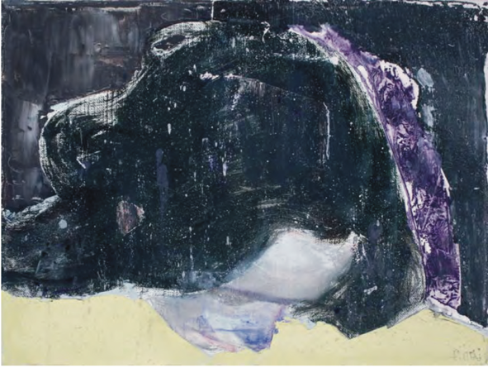

In the work of Moldova-born, Budapest-based Alexander Tinei, found images of strangers from the Internet provide the starting point for works that take portraiture and the human form into places that sit somewhere between abstraction and decay. As with Szücs, Tinei also sometimes depicts decapitated heads – the painting Mountains Are Crying Too (2017) represents the head of an androgynous young person at an acute angle, the face pointing downwards in sharp perspective. Their straggly black hair commands the composition, mixing in our minds with the painting’s title to take on the semblance of dark cliffs. Scuffed and scarred, the human head, hanging as if in sorrow, transmogrifies into a weathered rock in a bleak landscape. For Tinei, the mind, soul and spirit are deeply intertwined with the physical world, and mountains have a particularly rich history when it comes to being more than mere inanimate matter.

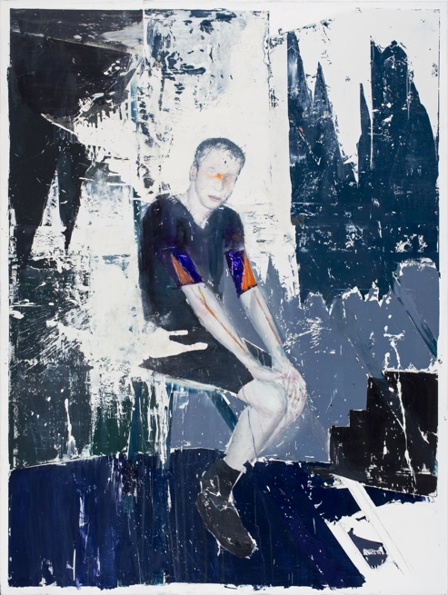

In a work such as Moon Brother (2016-17) a young man with pasty white skin wearing a dark T-shirt and shorts sits on a chair with his hands resting on his knees. He stares straight at us, his head twisted slightly. It feels as though he is specifically posing for a photograph but the normality of his posture and clothing are the only things that are normal about him. His eye sockets and the bridge of his nose are strangely stained orange, and thin orange lines flow down his arms like toxic varicose veins. The space in which he sits is a small, odd room or studio, the walls a scruffy mixture of uneven passages of white, black, navy blue and Payne’s grey, deteriorated as one might expect to see when old wallpaper has not peeled off easily, or when billboard posters have decayed in the wind and rain. The kind of backdrop one could imagine for a photo shoot for a fashion magazine, the shabby abstraction of the room infiltrates the body of the young man, a splatter of scuffed white paint spilling over his shorts. The boy, like the environment in which he sits, is partly eroded. The whole image is evocative of a photograph that has been left outside for a long time or damaged by chemicals, the surface partially worn away leaving the white paper exposed underneath.

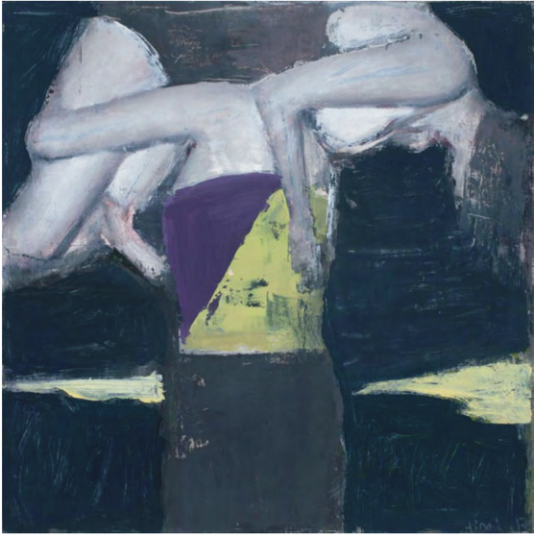

Tinei’s work regularly focuses on young people – men and women from roughly late teenage years through to their early thirties – perhaps drawn to their youthful energy, the fun times and to the powerful emotions these years often represent in people’s lives as well as to the fashions and lifestyles specific to this subsection of society. We see paintings of young couples kissing, a kid lounging on a sofa next to an electric guitar, and numerous examples of boys and girls messing around with each other physically, hanging around, planking or doing improvised gymnastics. In an untitled work from 2017, a young woman in a leotard is carried over the shoulder of what appears to be another girl. Closely cropped on all edges of the canvas, the viewer has a sense of being close up, as if part of the action – another friend who is part of the game. But while there is a sense of youthful playfulness, of being carefree and broke, there is almost always an underlying sense of darkness or danger in Tinei’s works. In this particular painting, the black paint that surrounds the two figures gives the impression that this is a night-time scene, and the starkly illuminated white flesh suggests the flash of a camera or the blue light from an LED torch. Skilfully though roughly painted, there is a sense of the grungy, edgy rawness that comes with youth – the unwashed hair of staying over at someone else’s place for the night after a party, the clothes that got put on again when they were already in the pile for washing, the awkwardness of an uncertain embrace. Tinei captures the visceral emotions, the subcultural aesthetics and the addiction to the unknown, to risk and excitement that characterises the lives of those young people not yet ready, or forever unwilling, to resign themselves to the boring routines, sensible behaviour and plain old hard work necessitated by regular adult life. Tinei’s world is the twilight of adolescence and the inescapable march of time, all, of course, haunted by the shadow of our own mortality.

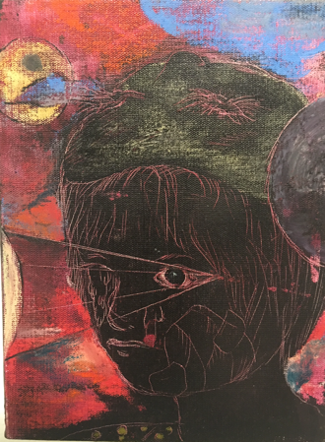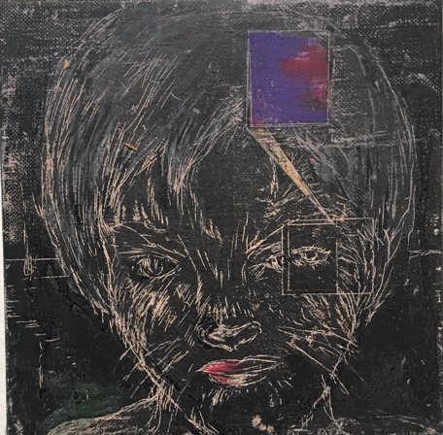

The work of Prague-born and based Josef Bolf has a similar sense of tenebrous melancholia – a darkness that is tinged with detachment, regret and a peculiar underlying current of anomie. In some of his most recent works, there is a mystical, almost alchemical aspect to the visual language, with graphic projections from eyeballs suggestive of supernatural capabilities and the ‘third eye’; faces superimposed over other faces as if possessed by benign though forlorn spirits; and children with hair and whiskers covering their faces, like young werewolves in the making. Bolf’s work spans a spectrum of reality, from the almost real through to the completely fantastical, from borderline normality to utter surrealism. Like troubled dreams, we might encounter human forms interspersed with landscapes and architecture, overrun by swirling, unidentifiable shapes and forms that are poised between menacing organic matter and disturbing abstractions. In other works, we might find ourselves standing behind a boy or young man in a doorway, facing outwards into a smoky, dusky landscape as if in the midst of a volcanic eruption. The boy holds a mirror up to his face, keeping a watchful eye on us over his shoulder.

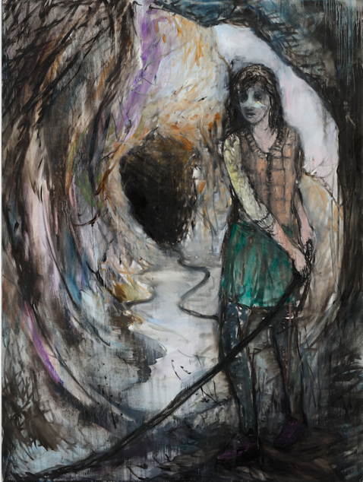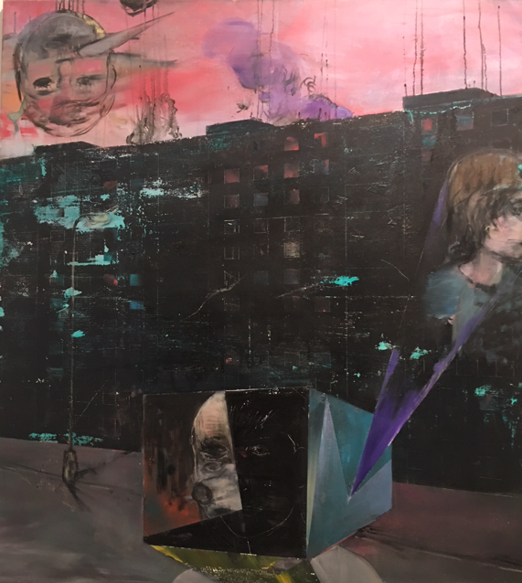

In the painting Recovered Connection (2017), a young woman stands in a tunnel or a cave, the section immediately behind her illuminated by what feels to be natural light from above. This illuminated shaft is in stark contrast to the pitch-black hole behind her, out of which comes a long thin tube or hose of some kind, which she holds with both hands to one side of her body. Perhaps it is a rope being used to lower someone down, or for a rescue. Her nose appears to be covered with a white plaster, partially obscuring her features. There is almost timeless drama and adventure here, though the narrative remains, in part at least, elusive. Another work in which an approximate moment in time is unclear, and yet which conveys a powerful sense of the passing of time, is the painting Ruins (2015), in which a head and torso, as if belonging to a young boy, are rendered in thick black outlines over a foggy grey landscape. Out of the greyness emerge buildings in ruins, either from fire or some slower demise. With broadly horizontal scratches, scrapes and scuffs across the surface, the painting itself feels to have been exposed to the elements and to the passing of time – to the inevitable decay that together they bring.

While many works appear timeless, others are more clearly tied to modern life, with vast apartment blocks virtually silhouetted against brooding pink skies, clouds of purple smoke rising from behind and windows glowing red as if a fire might have broken out. An outline of a baby-like head (disembodied, it should be noted) floats in the sky, a sharp horn emerging from its forehead, as if an omen from the gods or the angry spirit of an innocent victim between this world and the next. In the foreground a figure has its head covered by a box, from the side of which emerges a projection with the head of a young boy coming out of its purple light. While we can’t be sure as to the narrative, there is a clear sense of danger, destruction and death being played out through dimensions beyond our own. Perhaps tragedy has repercussions beyond reality.

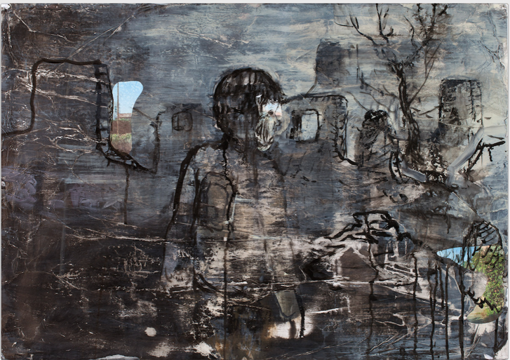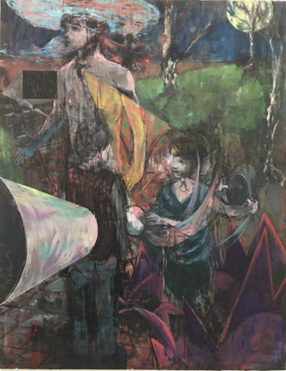

In the painting [Title and year TC XXXX] Bolf depicts a scene that on first inspection appears to be close to a rational three-dimensional space – a tall, thin, young effeminate man stands in the foreground, his back to a moonlit landscape as he stares out of the canvas to the left and into the distance. To his side are a number of children – at first there appear to be two younger boys, but then other heads come into focus – a girl with a hood, and yet more boys’ faces. As the viewer’s eyes acclimatise, it becomes clear that there is something unusual happening. An ellipse in front of one of the boys is the end of a projection emanating from the chest of the older young man, offering a portal through which the younger boy hands a smaller circular object to the boy in front of him. This circular object might be a mirror, reflecting silvery light, though it seems to transform into a large metal funnel as it emerges from the second boy’s back, as though he is a ghost. There are reflections and doubling at play, and it becomes difficult to disentangle the visible from the speculative, the real from the imagined, the physical from the metaphysical. A shimmering blue cloud hovers around the head of the older, taller boy, like an apocalyptic thought bubble. Clearly for Bolf, childhood and the journey to adulthood are not simple processes of ageing and growth but multi-dimensional conversations between memories, dreams and thoughts, symbolically made manifest through strange portals of projections, reflections and light amid the darkness.

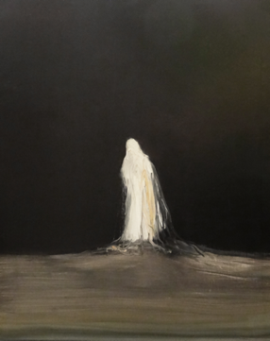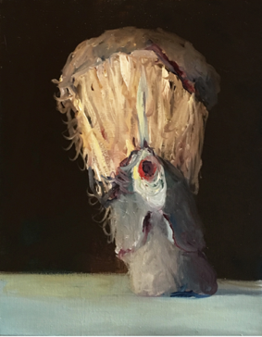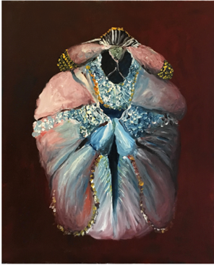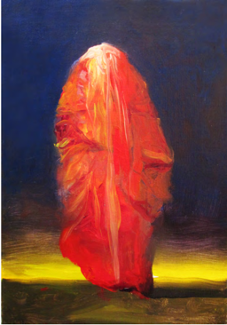

It is an equally strange world that can be found in the work of Bilbao-based Spanish artist Joseba Eskubi, though his is one that is attached to reality by the thinnest of threads. Known for his weird and wonderfully amorphous forms, Eskubi is an artist whose imagery is highly evocative whilst never quite becoming the things it evokes. What might be suggestive of a butterfly could also call to mind a ballerina’s dress, the body of an insect might also be a precious item of jewellery, what might be perceived as a bird could equally be an ornament. Curious clumps of matter are presented in surprising configurations, the organic and the inorganic intertwined in such strange ways that the viewer can never be entirely sure if they are looking at something living, something that once lived, or something that has never been alive. They are neither fish nor fowl. There is also the rather disturbing possibility that the things he paints have been brought to life by unnatural means – as if through magic or witchcraft. Indeed, there is something distinctly totemic, or talismanic, about many of Eskubi’s paintings – feathers and hair, fabric and stones, limbs and flesh conspiring to suggest exotic fetishes from civilisations unknown.

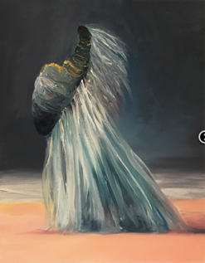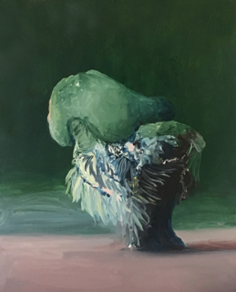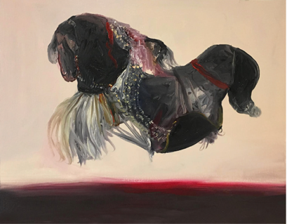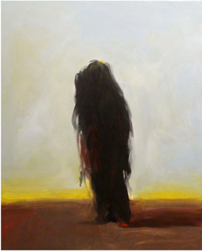

In many works, these mysterious objects float in the air, suspended against a backdrop of pure or muddied colours – from black to putty, murky pink to rusty orange, dingy blue to sickly yellow. On other occasions, the objects are set in a landscape of sorts, with almost abstract bands of land, sea, horizon and sky variously merging and separating. While the Earth offers great variety in the colours of the natural environment, the geology of Eskubi’s landscapes often feels to be not of this world, as though we are looking at the surfaces of planets in distant galaxies. In some instances, the viewer is left to ponder the scale of the imagery depicted – are we looking at a large object in the distance, or a small object close up? As our minds struggle to rationalise the object itself, our understanding of the environment surrounding it is destabilised, resulting in conflicting sensations of intimacy and detachment, proximity and perspective. Similarly, the viewer would be justified if they felt uncertain as to the weight of Eskubi’s creations – some heavy-looking forms appear to float with ease, while other lighter-looking things seem to hover just above the ground, or to be on, or buried in, the surface. Rocks that might be animals, fantastical creatures that might be masquerading as flotsam and jetsam from the delirious mind of a rogue taxidermist, and billowing apparitions that threaten to take on human form are just part of Eskubi’s lexicon, a language of amorphous matter evolving towards the biomorphic and anthropomorphic, a language of odd dreams on the cusp of turning into nightmares. These things, these beings, are often so close to being human they appear to have the proportions of the body, complete with limbs, heads and sometimes even faces, yet there always remains something not quite human, not quite fully conscious about them. As could be said for all of the artists in this exhibition, there is a sense in Eskubi’s work that we are not looking through rational eyes at the real world, but rather through a filter of sleep, or of the subconscious, or of fantasy. In painting we are perhaps always looking at an illusion, and even in the darkest corners of abstraction, we are inevitably entering a liminal space that is just beneath reality.

‘Art exists because reality is neither real nor significant.’
–J.G. Ballard

‘The Benign Catastrophist’. Interview with J.G. Ballard by Susie Mackenzie, www.theguardian.com. 6 September 2003. https://www.theguardian.com/books/2003/sep/06/fiction.jgballard (accessed 16 July 2018)
Attila Szücs in conversation with the author, Budapest, December 2016.
‘JG Ballard: Theatre of Cruelty’. Interview with J.G. Ballard by Jean-Paul Coillard, Disturb ezine, 1998 http://www.jgballard.ca/media/1998_disturb_magazine.html (accessed 24 July 2018)

